Bad Visualization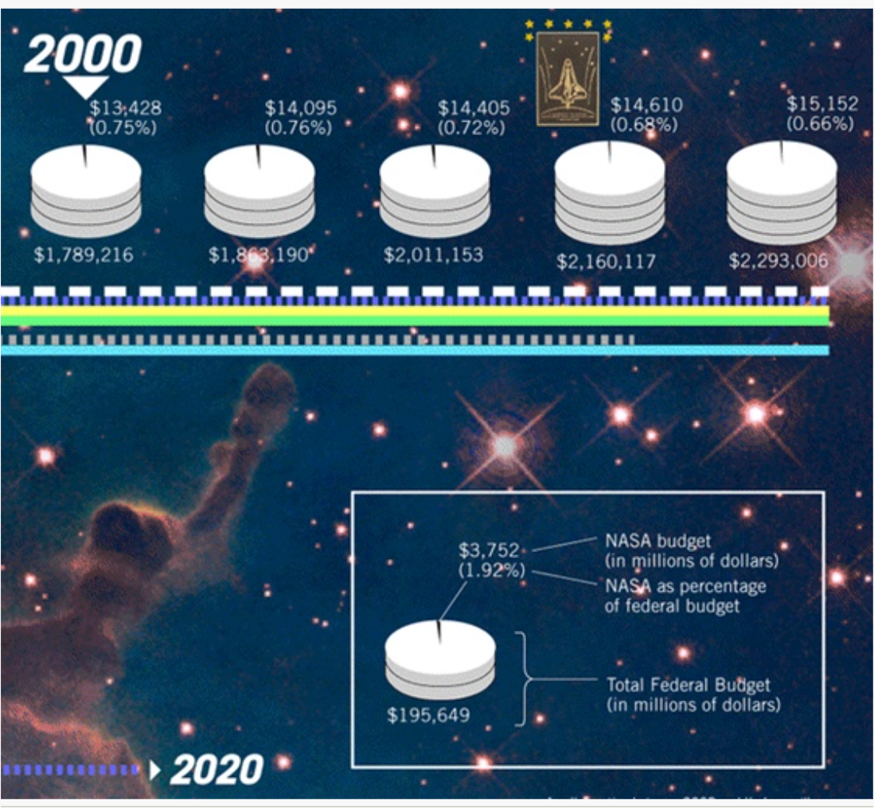

This visualization intends to show the change in the NASA budget as a percentage of the federal budget. However, there is a lot that is unclear about this visualization. The timeline is not clear at all. It appears to begin in the year 2000 but does not label any of the other charts with a year. The year 2020 is randomly at the bottom of the graph, but I do not know what that means in context of the graphs.

This visualization does not follow any of the guidelines for effective visualizations. Firstly, there are unnecessary design aspects that do not contribute to understanding the information portrayed. The random lines underneath the circle graphs do not add any information or further understanding -- and they actually do harm to the visualization by adding clutter. To be aesthetically beautiful, visualizations should be free of any unnecessary elements. All they do is confuse the viewer. The icon of the spaceship and the space background do not add information, but it does prompt the viewer to know that the graph is related to space, so I do like that part.

Another issue is that all three of the circle graphs shown look the exact same at first glance. When you look further at the details, you can see that the number of disks stacked on top of each other increases -- but it is difficult to make out. Visualizations should be readable and as easy as possible to understand, but this one is difficult to dissect meaning from at all.

The tiny sliver of the circles that represent the NASA budget are also difficult to see. It does look like the sliver gets slightly smaller over time. However, it is difficult to draw that conclusion because the viewer must account for the fact that there are now additional disks stacked. Thus, it is difficult to consider this visualization insightful when it is so difficult to draw any meaningful patterns. Lastly, an additional issue with this graph is that the circles are 3 Dimensional. 3D shapes should be avoided in visualizations because they can misrepresent the size of data.

It is difficult to understand what message this visualization is attempting to get across. It may be trying to show how the federal budget increases over time but the percentage going to NASA decreases, but that message is certainly not communicated effectively through this display. Below are some redesigns that could better get this message across:

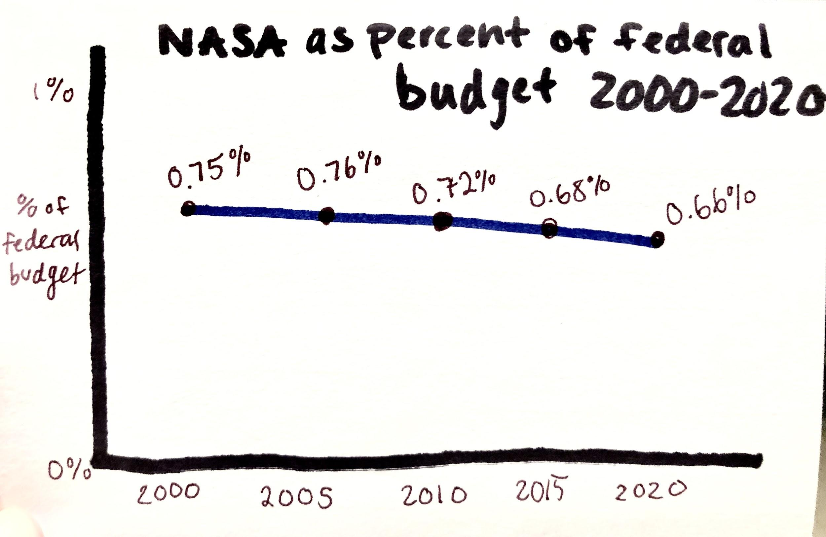

My first redesign is a line graph that more clearly illustrates the change in the federal budget versus the NASA budget. The first graph shows the percentage of the federal budget that NASA is given and the way it changes over time. From this line graph, the viewer can clearly see that the budget percentage NASA is given decreases over time.

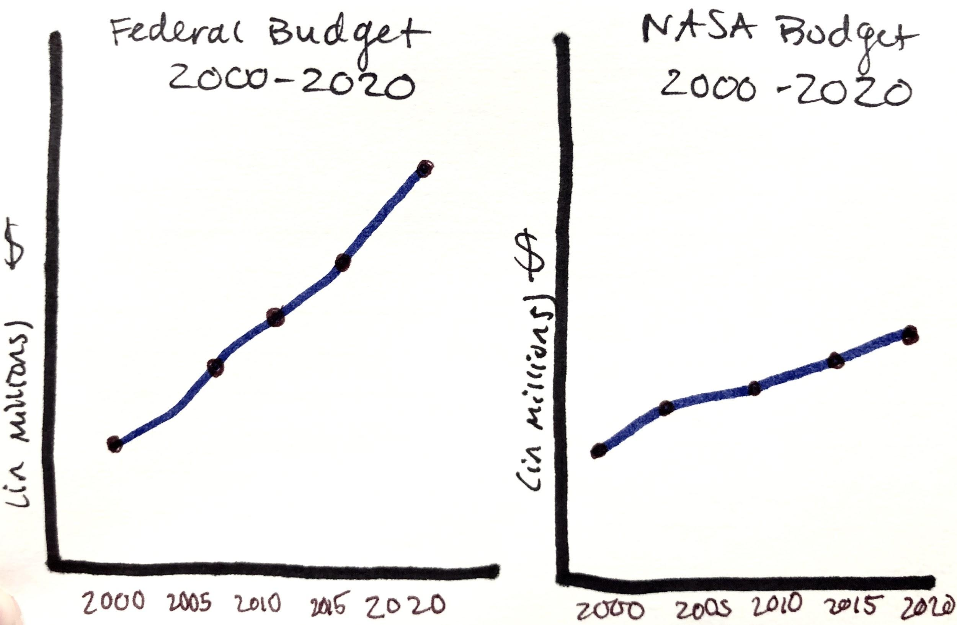

The second redesign shows a clear comparison between the change in the federal budget and the change in the NASA budget, in millions of dollars. The graph shows that the federal budget increased sharply over time. However, the graph on the right shows that the NASA budget hardly increases at all over 20 years.

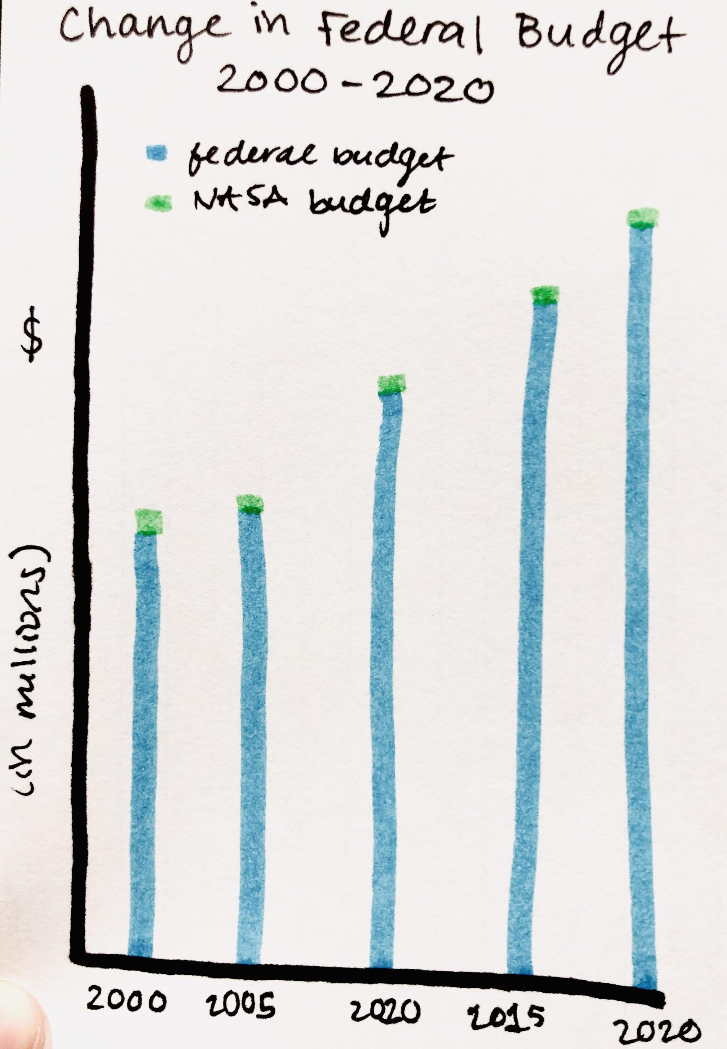

The redesign that I believe would be most effective is a stacked bar chart. This shows the clear upward progression of the federal budget over time. The part of the bars that represents the NASA budget is clearly distinguishable by the different color. And by contrasting the way the larger bar gets bigger and the small red segment does not, the viewer can clearly conclude for themselves that the federal budget drastically increased over the years while the NASA budget stayed relatively stable. The compromise I had to make by choosing this graph is that it is difficult to see any change in the NASA budget segment because of how small it is (even though it did change by millions of dollars). But in context to the federal budget at large, it makes sense why it is difficult to make out any change.

Good Visualization

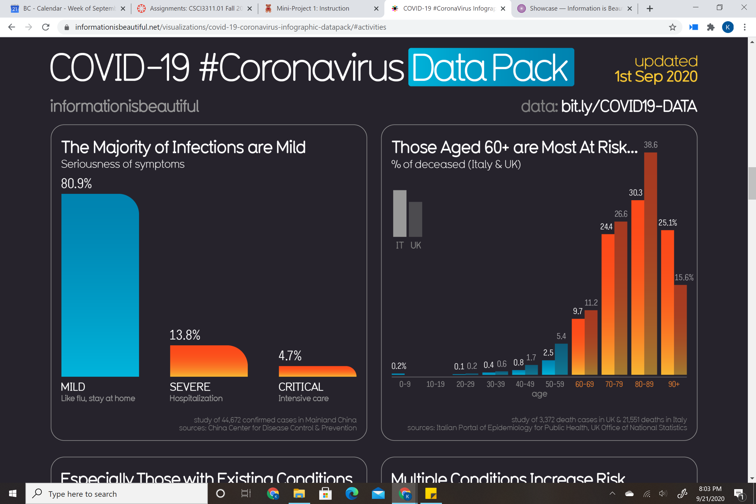

For my good visualization, I chose this visualization detailing deaths from coronavirus in Italy and the UK. I found this visualization to be very effective because it clearly shows the percent deceased is highest in those in their 80’s. This is an important visualization because it has the potential to save lives. If people who are 60+ in Italy or the UK see this visualization, it may convince them to stay at home and avoid risky social events by which they could catch the virus. In this sense, this visualization could save lives.

This visualization is effective because it is quick and easy to understand, while conveying a large amount of information at the same time. A harmful impact of this visualization could be that if a 10-19 year old sees this visualization, they may take away the message that they are invincible and that there is “no chance” they could die from the virus. This may result in reckless behavior that could endanger them and spread the virus further, which harms communities and their country at large. Because of this, I believe it would be wise to show this graph to older viewers as a target audience.

When viewers see this visualization, they can easily identify extremes, make comparisons, and see trends in age all at once. It is truthful, functional, beautiful, insightful, and enlightening. The one thing I don’t like about this is that the difference between the way Italy and the UK are difficult to distinguish from one another. Italy is supposed to be lighter, but it is not a drastic enough difference to see at first glance.